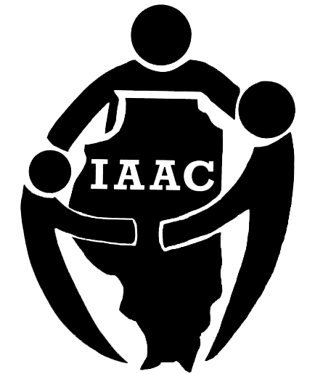
Illinois Adoption Advisory Council

The Illinois Adoption Advisory Council (IAAC) is charged with advising DCFS on all matters involving or affecting the provision of adoption and guardianship services. They are the voice of adoptive and guardianship families to help guide, support and implement change.

We need adoptive parents, adoptees, and professionals with the following qualities:
- Has the time, energy, and resources to attend council meetings held from 9am to 3pm on Fridays six to eight times per year at sites around the state, reasonable travel reimbursement at DCFS expense, based on State travel regulations.
- Will attend and participate in AAC meetings and serve on at least one of its committees, participating in conference calls between AAC meetings to do committee work. DCFS provides conference call line.
- Has access to childcare resources if needed, reimbursed at the State rate.

The Director makes all final appointments to the IAAC in writing. Once a prospective member has been recommended, the Office of Caregiver & Parent Support will contact him or her to discuss the opportunity. Completed applications will be vetted through the appropriate channels listed in the IAAC bylaws before becoming a recommendation to the Director.

To recommend prospective members to serve on the Illinois Adoption Advisory Council, please email their name and contact information to:
DCFS.AdoptionAdvisoryCouncil@illinois.gov.

Application For
Adoption/Guardianship Service Professionals

for Appointment to the
Illinois Adoption Advisory Council

Name
Email Address
Mailing Address
Phone | Office: Cell:

How long have you been involved in the adoption field as an adoption / guardianship service professional?

Did you ever adopt or were you adopted through the child welfare system, internationally or privately?

Have you been actively involved in adoptee or adoptive parent groups, such as committees, support groups, etc? YES NO

If Yes, please list which group(s) and describe how you have been involved:

Why do you want to serve on the Illinois Adoption Advisory Council and what will you contribute to the council and its committees?

Please explain any other experience, education, Training, etc. that would benefit you in your role on the Council.

How will you plan to contribute to racial equity and diversity efforts for youth and families?

Please send this completed form, a current resume and
two character recommendations related to your adoption experience to:
DCFS Office of Caregiver & Parent Support
406 East Monroe, Station 225
Springfield, IL 62701
Or email DCFS.AdoptionAdvisoryCouncil@illinois.gov

